I ran for16x16x16 region (N=4096 particle) and density=0.02 the input file. My result is next to page and my input file is bellow.When I ran for 8x8x8 region(N=512 particle) and density=0.3 it, Program is giving the error as following(because energy is very much).

Step Temp TotEng Press Volume PotEng
0 1.9 4.6993414e+35 -1.8551831e+39 1333.3333 4.6993414e+35 nan nan nan nan 0 nan nan nan nan nan nan nan nan nan nan nan
….

Dear Dr. Roberto Berardi have obtained liquid crystal phase transition for N=512 and density=0.3 by monte carlo simulation but I don’t obtain phase transition for N=512 and density=0.3 by LAMMPS.

1-For this reason I dont sure whether my result is consistent with literature values.???

2-Why I dont obtain phase transition for N=512 and density=0.3 by LAMMPS???

İnput file:
units lj
atom_style ellipsoid

lattice sc 0.02
region box block 0 16 0 16 0 16
create_box 1 box
create_atoms 1 box
set group all quat/random 982381

mass 1 1.5
shape 1 1 1 3
compute rot all temp/asphere
velocity all create 2.0 41787 loop geom

pair_style gayberne 1.0 3.0 1.0 4.0
pair_coeff 1 1 1.0 1.0 1.0 1.0 0.2 1.0 1.0 0.2 4.0
neighbor 0.3 bin

timestep 0.002
thermo_style custom step temp etotal vol epair press pe
thermo 100

fix 1 all npt/asphere 2.0 2.0 0.1 xyz 0.0 8.0 0.1
run 50000
unfix 1
fix 1 all npt/asphere 2.0 2.0 0.1 xyz 8.0 8.0 0.1
run 50000

My simulation result is result: density=0.02 region 16x16x16 (N=4096 particle/molecule)

this is mine
T | <U>
1 | -17,0145
1,2 | -16,024
1,4 | -15,6726
1,6 | -15,6523
1,8 | -14,9684
2 | -14,2135
2,2 | -13,422
2,4 | -12,6006
2,45 | -11,8202
2,5 | -9,14463
2,6 | -8,3759
2,8 | -7,29862
3 | -6,23544
3,05 | -4,60693
3,1 | -3,99733
3,2 | -3,22998
3,4 | -2,90018
3,6 | -2,61
3,8 | -2,39351
4 | -2,20946
4,2 | -2,06759
4,4 | -1,91073
4,6 | -1,77684
4,8 | -1,66672
5 | -1,53614
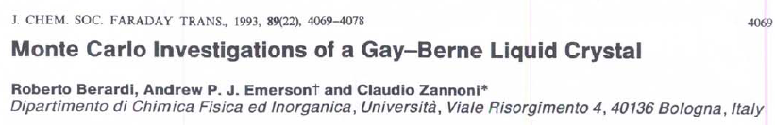

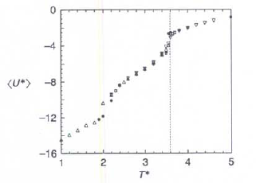
Figure: Roberto Berardi, density=0.3 N=512,Pressure=8

