Hello user：
I am trying to calculate the stress-strain curves during tensile-induced crystallization. My date file containing 200 chains with chain length of 200 UA model and CNTs. Then, I run my system based on the in file, the content of which can also be seen in the following sections.
But the fluctuation of the stress-strain curve has a very strange phenomenon. As can be seen in the following picture, the stress-strain curve (The length of cnt is 36.89 and the number is 4, m=n=7) fluctuates too much. I don't know where is the problem in the in file and how to smooth the stress strain curve. Please give me some advice.
I really appreciate your help.
THANKS.
Here is my stress-strain curve:
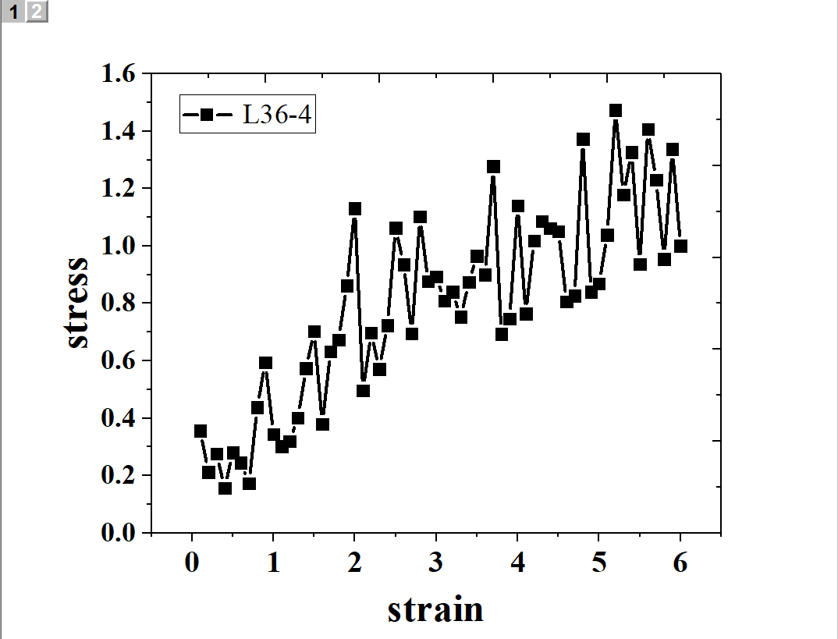
Here is my in file:
units metal
dimension 3
boundary p p p
atom_style molecular
read_data Poly.data
pair_style hybrid/overlay airebo 3.0 0 0 lj/cut 10
pair_modify tail yes
bond_style harmonic
angle_style harmonic
dihedral_style fourier
pair_coeff 1 1 lj/cut 0.004857 4.01
pair_coeff 1 2 lj/cut 0.004944 3.71
pair_coeff * * airebo ./CH.airebo NULL C
bond_coeff 1 15.1795 1.53
angle_coeff 1 2.6022 109.5
dihedral_coeff 1 3 0.03513 1 0 -0.01865 2 0 0.07026 3 0
neighbor 2 bin
neigh_modify every 1 delay 0 check yes
minimize 0.0 4.336e-10 1000 100000
min_style cg
run_style verlet
# reset_timestep 0
timestep 0.001
fix 1 all npt temp 400 400 0.1 y 1 1 1 z 1 1 1 drag 0.5
fix 2 all deform 1 x erate 1e-2 units box remap x
thermo_style custom step temp etotal pe epair ebond eangle edihed density lx ly lz pxx pyy pzz
thermo 1000
compute 4 all rdf 200 1 1
fix 3 all ave/time 3000 1 3000 c_4[*] file temp4.rdf mode vector
variable l_x equal lx
variable lx0 equal ${l_x}
variable strain equal (lx-v_lx0)/v_lx0
variable stressx equal "-pxx/1000"
variable stressy equal "-pyy/1000"
variable stressz equal "-pzz/1000"
fix 4 all ave/time 1 300 100000 v_strain v_stressx v_stressy v_stressz file strain_stress.txt
thermo_style custom step temp v_strain v_stressx v_stressy v_stressz pe etotal epair ebond eangle edihed density lx ly lz pxx pyy pzz
thermo 1000
dump lashen1 all custom 100000 lashen1.lammpstrj id type element x y z ix iy iz
dump_modify lashen1 sort id pad 6
dump lashen2 all custom 10000 LSdump.*.txt id mol type x y z xu yu zudump_modify lashen2 sort id pad 8
run 600000
undump lashen1
undump lashen2
unfix 1
unfix 2
write_restart restartLS.equil
write_data dataLS.polymer

