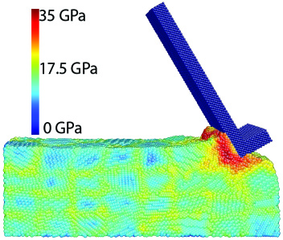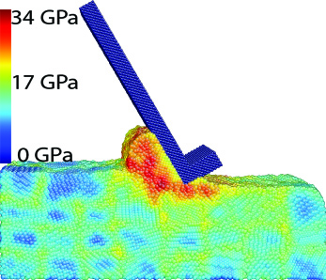
Equivalent stress distribution in the machining of monocrystalline copper for case 3 at: (a) 24 ps, (b) 48 ps

