Running LAMMPS on windows platform
- In order to run LAMMPS you should first download LAMMPS excutable from the following link (LAMMPS Windows serial executable)
http://lammps.sandia.gov/download.html
- Then copy your input file, data_file, potential file and lmp_win_no-mpi files in one folder. (In your case you have just input_file and no potential)
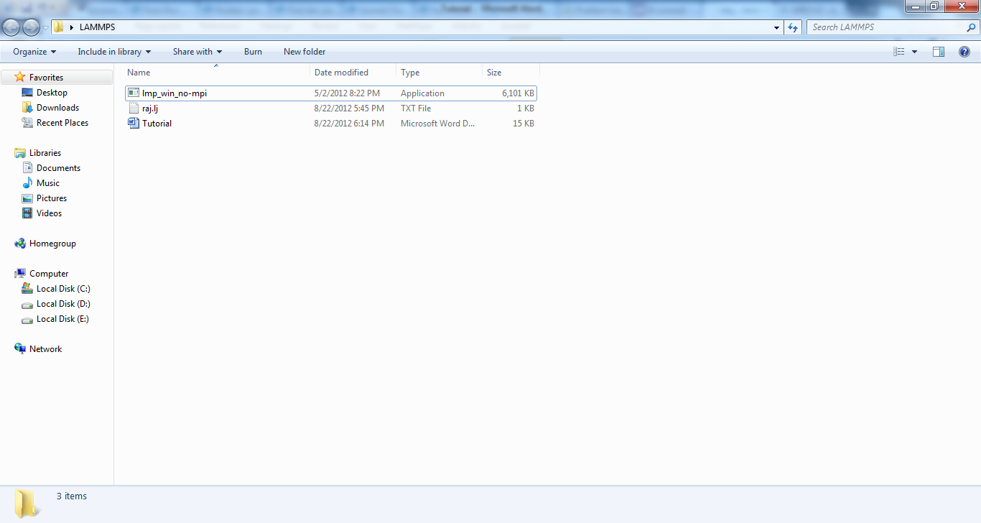

- In the mentioned window, Hold Shift key and right click on the window. From the list, choose “open command windows here”
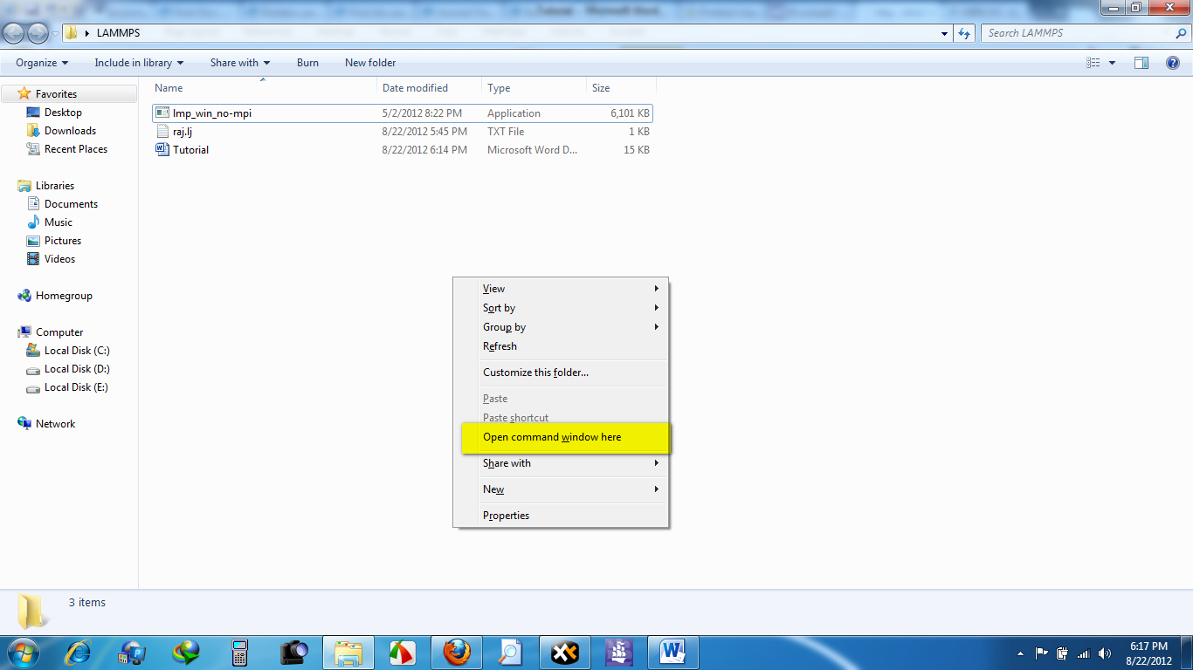
- When the command prompt opened, type the following command in the command line and press enter.
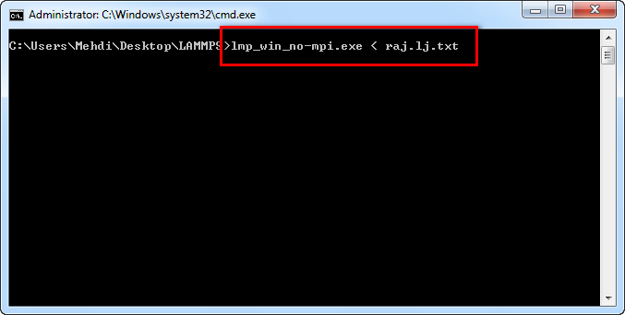
- After a while you will have the log file and the run is completed.
